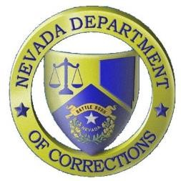
Nevada Department of Corrections

_________________________________
Public Information Office: 775-887-3309 PIO Scott Kelley Cell: 775-350-0037

Press Release
For Immediate Release:
February 25, 2020

The Nevada Department of Corrections (NDOC) reports that on Saturday, February 22, 2020 at approximately 12:45 a.m., inmate Carl Bradley, #94343 died at Carson-Tahoe Regional Medical Center in Carson City, Nevada. Bradley, a 33-year-old male, was a U.S. citizen and
Clark County commit serving a 60-150 months for Battery with a Deadly Weapon with
Substantial Bodily Harm and Ex-Felon in Possession of a Firearm. Bradley arrived at the NDOC on May 04, 2018. An autopsy will be scheduled per NRS 209.3815. Next-of-kin has been notified.

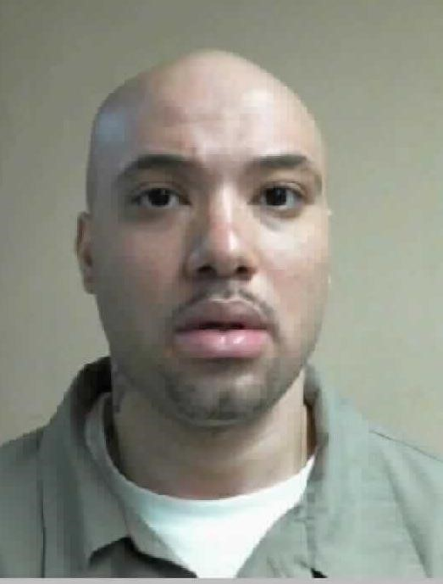

Carl Bradley
The Nevada Department of Corrections is committed to building a safer community by striving to incorporate progressive best practices in all aspects of corrections. NDOC houses nearly 14,000 persons with felony convictions in 18 facilities statewide. For more information visit www.doc.nv.gov.

